**How to add user?**

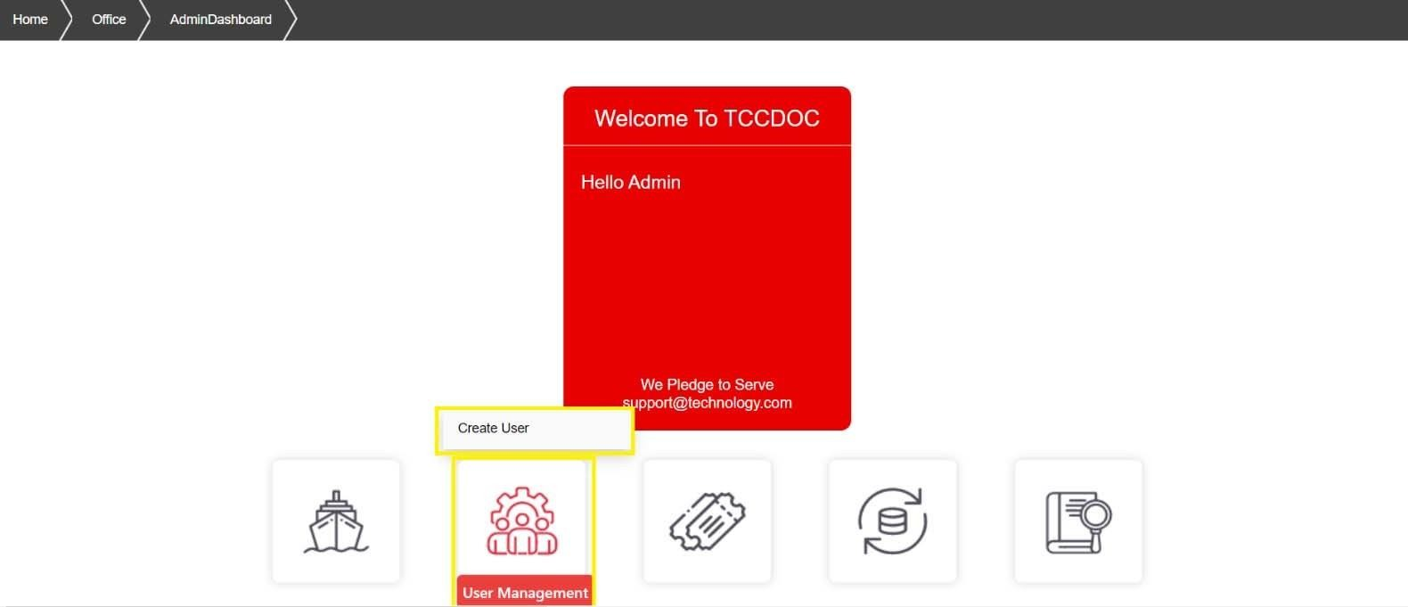

Click

here.

User can be added By Office Admin Only in the following steps:

1. By moving the cursor on the user management button, the  box pops up. Then click on the create user button as shown below:
2. After clicking on the create user button, a window will appear as shown below:

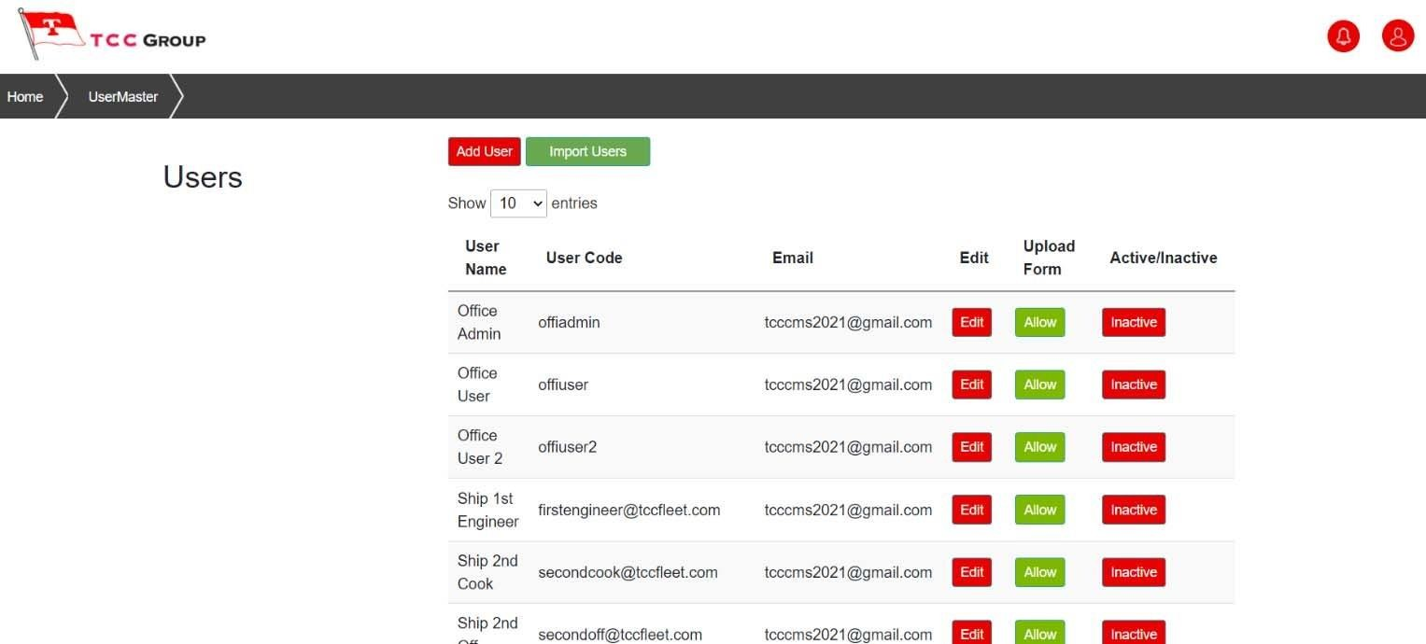

User can

be

added by clicking

1. Now after clicking the add user button, a window will appear where user can be created by filling up the details as shown below:

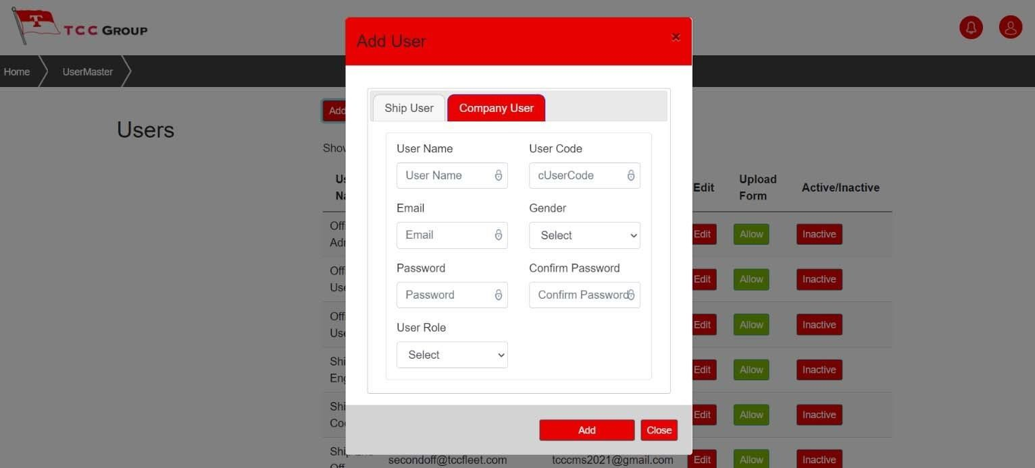

Window showing the

details to be filled.

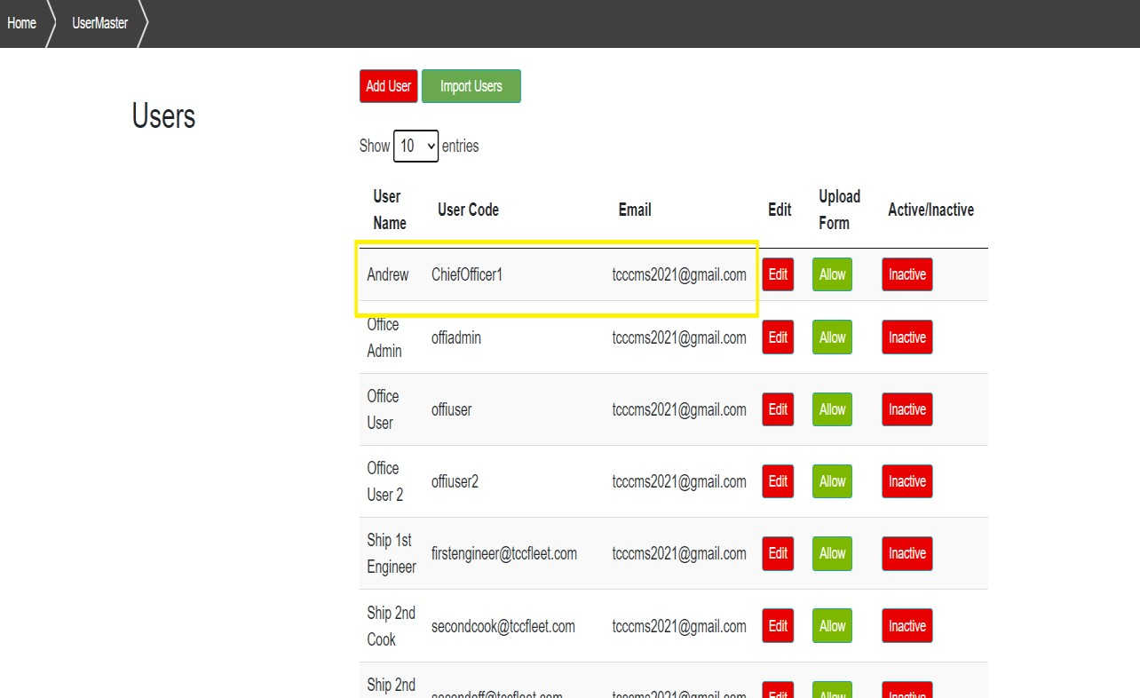

The above picture shows the new user is added now.